Odczytaj nazwy zwierząt, które widzisz na obrazkach, następnie odszukaj wszystkie litery tworzące tę nazwę i pokoloruj je. Powodzenia ☺

**kot**

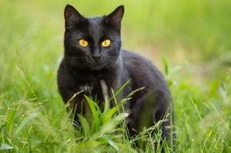

|  |  |  |  |  |
| --- | --- | --- | --- | --- |
| k | a | b | t | d |
| m | o | n | i | l |

**kotek**

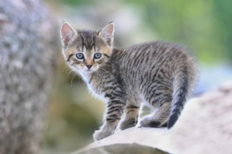

|  |  |  |  |  |
| --- | --- | --- | --- | --- |
| k | a | e | t | d |
| m | o | n | i | k |

**krowa**

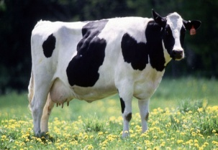

|  |  |  |  |  |
| --- | --- | --- | --- | --- |
| k | a | r | t | d |
| m | o | n | w | s |

**byk**

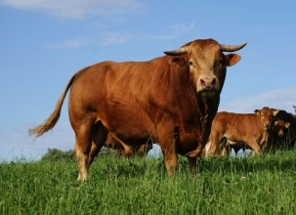

|  |  |  |  |  |
| --- | --- | --- | --- | --- |
| k | b | r | t | d |
| m | o | n | w | y |

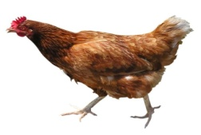**kura**

|  |  |  |  |  |
| --- | --- | --- | --- | --- |
| k | b | r | t | d |
| m | o | n | w | y |

**indyk**

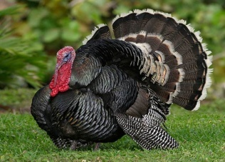

|  |  |  |  |  |
| --- | --- | --- | --- | --- |
| k | i | r | t | d |
| m | o | n | w | y |